Supplementary

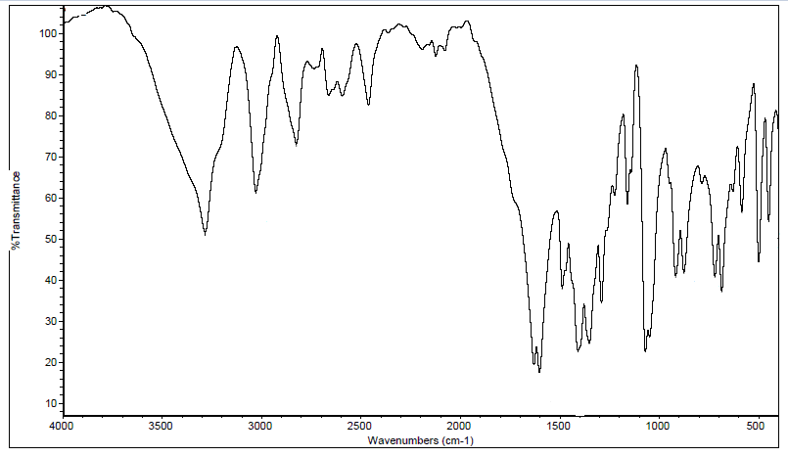
Figure S1: IR spectrum of tricine in KBr.
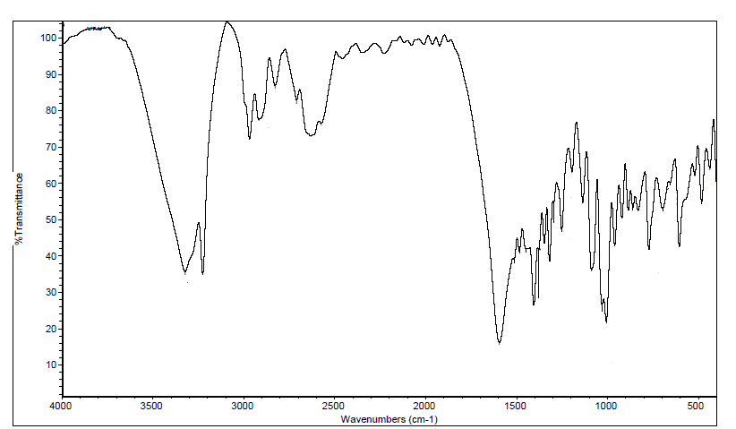
Figure S2: IR spectrum of [Ni(tric)₂Cl₂].3H₂O in KBr.
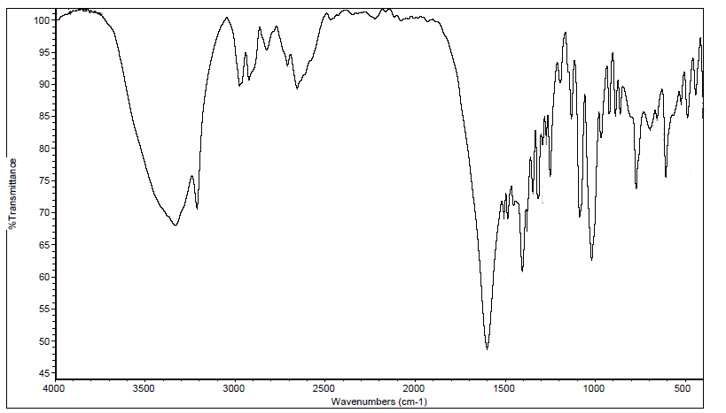
Figure S3: IR spectrum of [Co(tric)₂Cl₂].2H₂O in KBr.

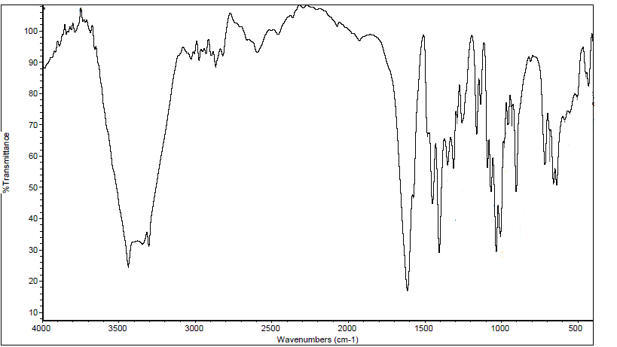
Figure S4: IR spectrum of [Zn(tric)₂Cl₂].EtOH in KBr.
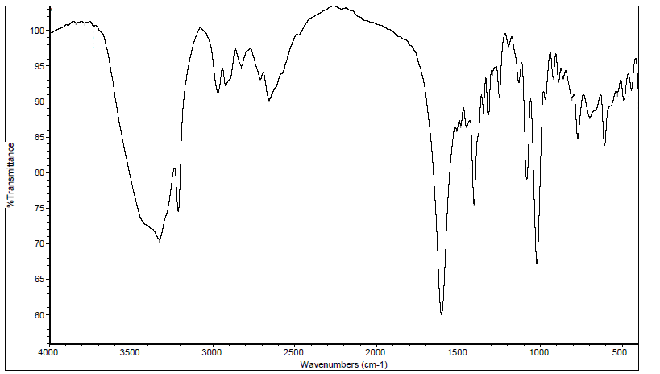
Figure S5: IR spectrum of [Cd(tric)₂(Ac)₂].H₂O in KBr.
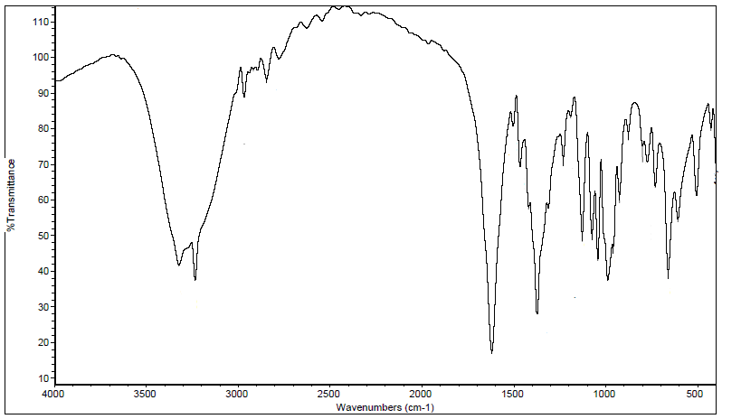
Figure S6: IR spectrum of [Ni(tric-H)₂].2H₂O in KBr.

Figure S7: IR spectrum of [Cu(tric)₂]Cl₂.3H₂O in KBr.

Figure S8: IR spectrum of [Co(tric-H)₂].0.5H₂O in KBr.

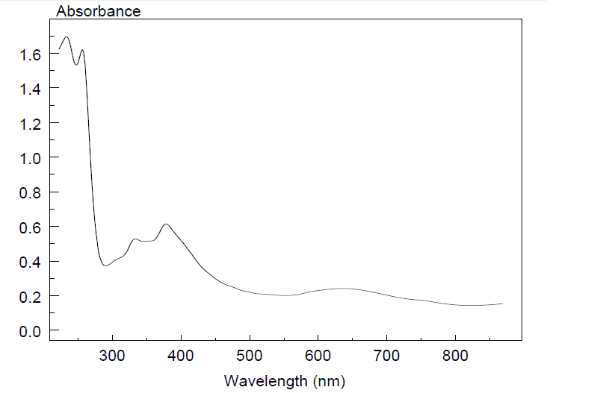
Figure S9: Electronic spectrum of [Ni(tric)₂Cl₂].3H₂O.

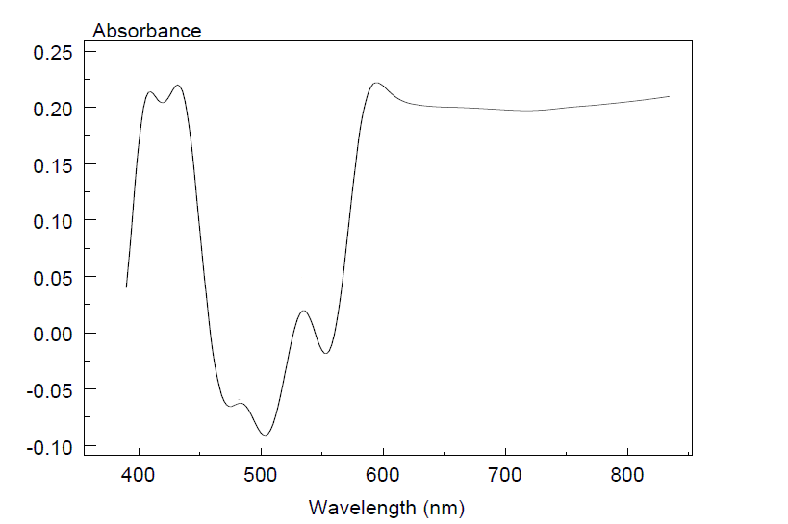
Figure S10: Electronic spectrum of [Co(tric-H)₂].0.5H₂O.
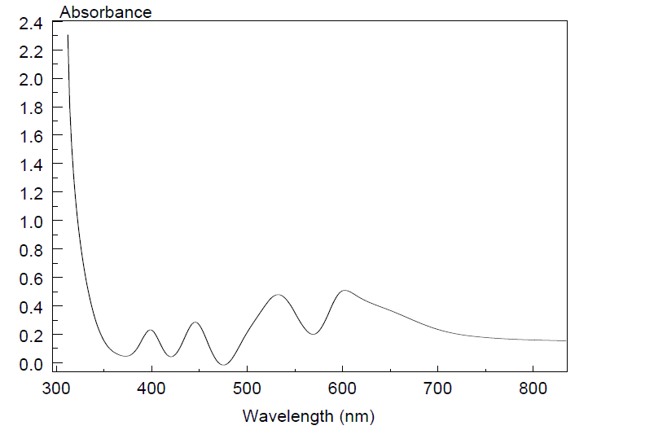
Figure S11: Electronic spectrum of [Co(tric)₂Cl₂].2H₂O.

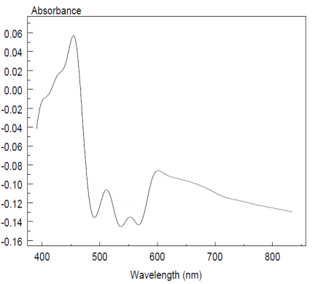
Figure S12: Electronic spectrum of [Ni(tric-H)₂].2H₂O.

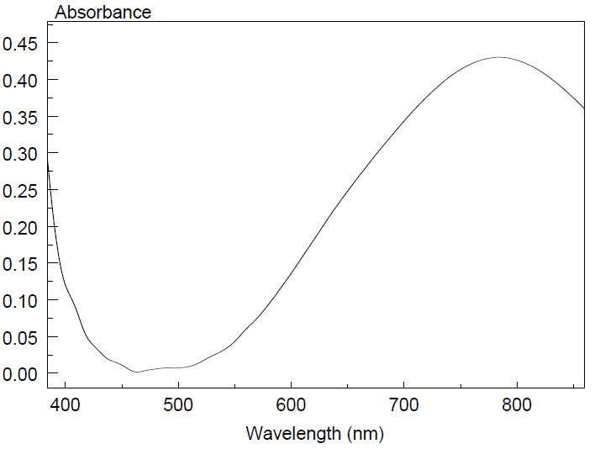
Figure S13: Electronic spectrum of [Cu(tric)₂]Cl₂.3H₂O.
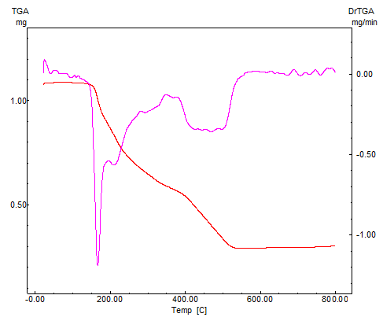
Figure S14: Thermal analysis curves (TGA, DTG) of [Cu(tric)₂]Cl₂.3H₂O.

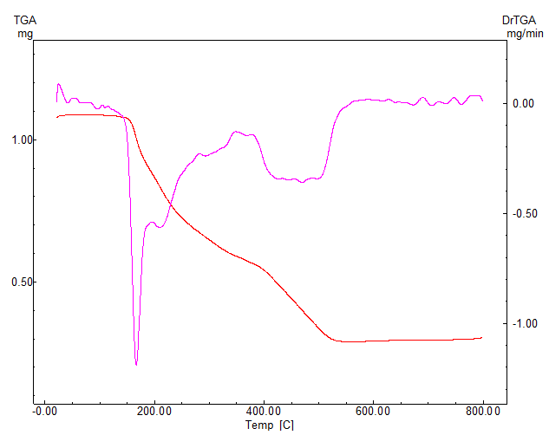

Figure S15: TGA curves of [Cu(tric)₂]Cl₂.3H₂O.
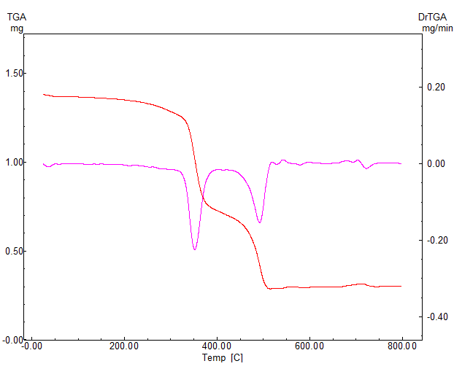

Figure S16: TGA curves of Co(tric)₂Cl₂].2H₂O.

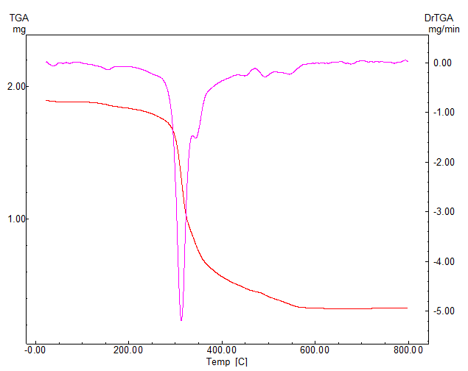

Figure S17: TGA curves of [Ni(tric)₂(Cl)₂].3H₂O.
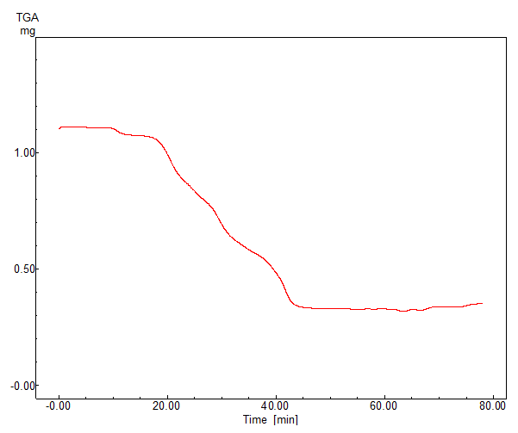

Figure S18: TGA curves of [Cd(tric)₂(Ac)₂].H₂O.

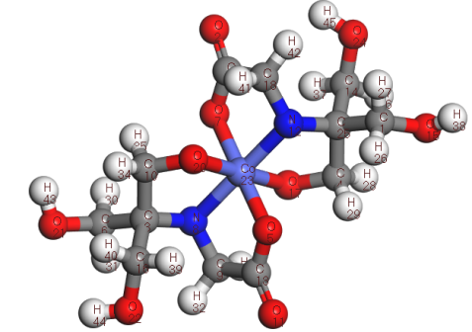

Molecular modeling of [Co(tric-H)₂].0.5H₂O.

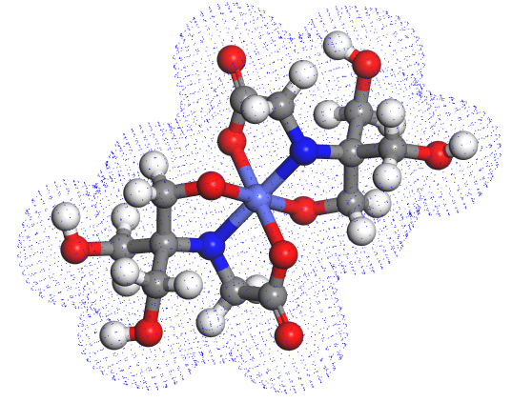

Electron density of [Co(tric-H)₂]. 0.5H₂O

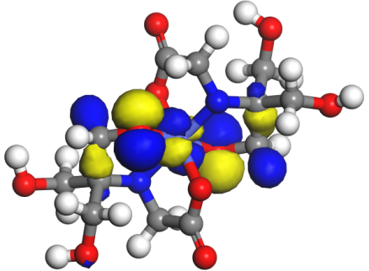

E_{LUMO} = -5.195 eV

ΔE = -0.308 eV

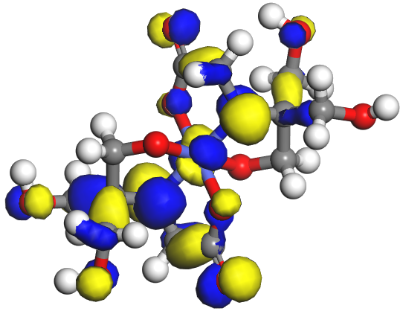

E_{HOMO} = -5.503 eV

Scheme S1: Molecular modeling of [Co(tric-H)₂]. 0.5H₂O.

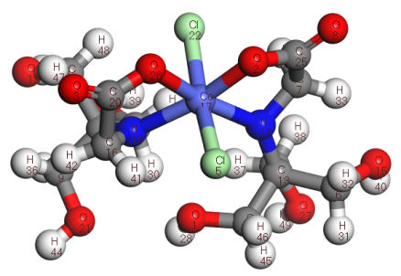

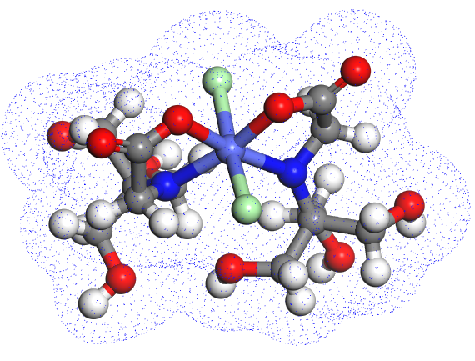

Electron density of [Co(tric)₂Cl₂].2H₂O.

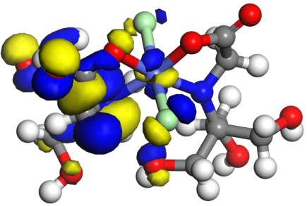

E_{LUMO} = -5.150

ΔE = -0.573 eV
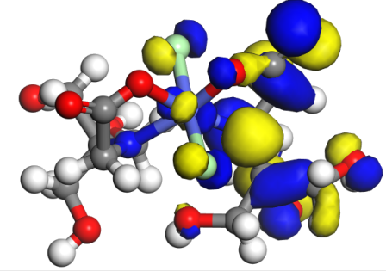

E_{HOMO} = -5.723 eV

Scheme S2: Molecular modeling of [Co(tric)₂Cl₂].2H₂O.
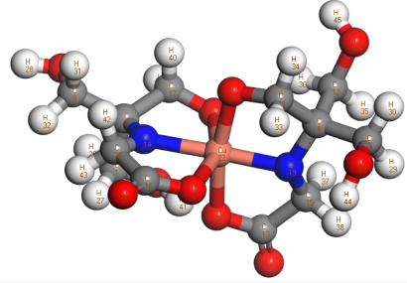
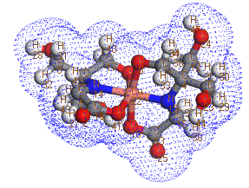

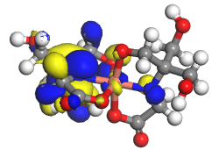
(a) (b)

E_{LUMO} = -4.958eV
(d)
ΔE = -0.32eV

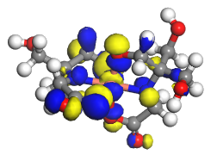

E _{HOMO} = -5.278eV

(c)
Scheme S3: Molecular modeling of (a) [Cu(tric)₂]Cl₂.3H₂O, (b) electron density,(c) HOMO and (d) LUMO.

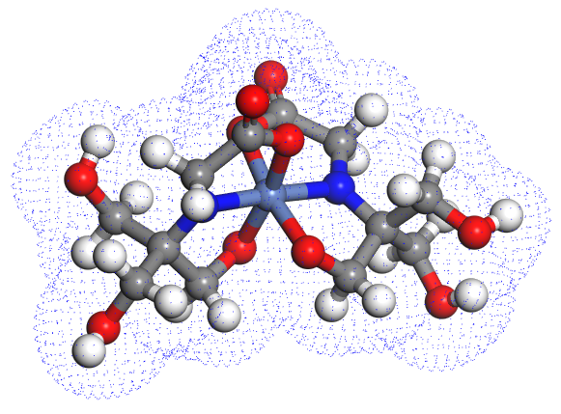
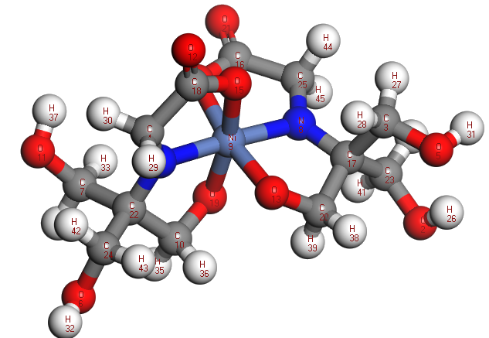

- (b)

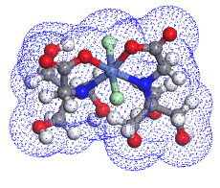
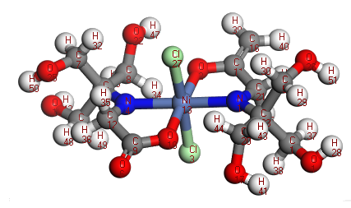

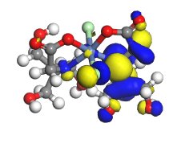
- (b)

E_{LUMO} = -5,328 eV

(d)
Δ E = -0.105 eV

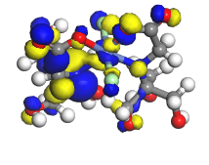

E_{HOMO} = -5.433eV

(c)
Scheme S4: Molecular modeling of (a) [Ni(tric)₂Cl₂].3H₂O,(b) electron density,(c) HOMO and (d) LUMO.

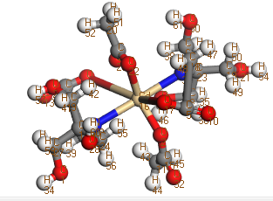
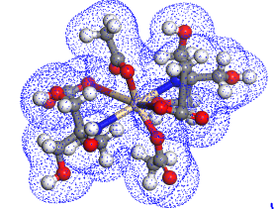

- (b)
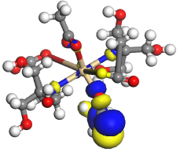

E_{LUMO} = -1.942eV
(d)

ΔE=-3.425eV

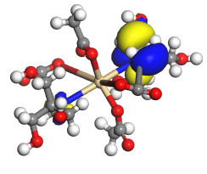

E_{HOMO} = -5.367eV
(c)
Scheme S5: Molecular modeling of (a) [Cd(tric)₂(Ac)₂].H₂O, (b) electron density, (c) HOMO and (d) LUMO.

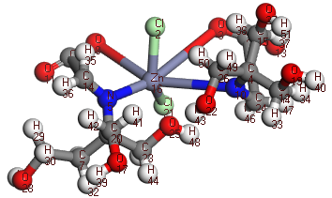
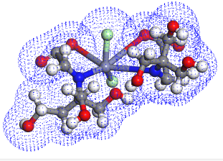

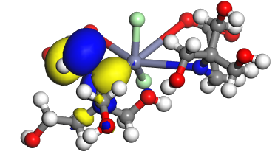
- (B)

E_{LUMO} = -2.530 eV

(D)

ΔE = -3.397 eV

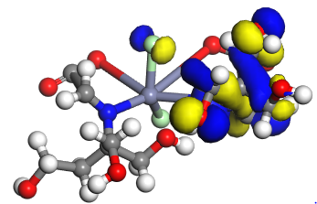

E_{HOMO} = -5.927 eV

(C)
Scheme S6: Molecular modeling of (a) [Zn(tric)₂Cl₂].EtOH, (b) electron density, (c) HOMO and (d) LUMO.

.
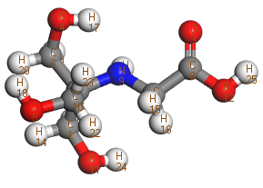
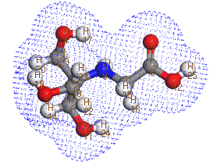

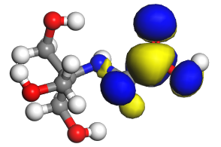
(a) (b)

E_{LUMO} = -0.678 eV

(d)
ΔE = -4.502 eV
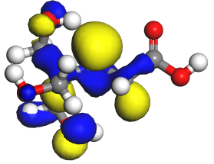
E_{HOMO} = -5.180 eV

(c)
Scheme 7: Molecular modeling of tricine (a), electron density (b), HOMO (c) and LUMO (d).
Table S1: Thermal analysis (DTA, DTG) of the complexes.
Compound, No. | Decomposition Step | Temperature  range  ﹾ)C) | Remove species | Wt. Loss
 |  |  |  | % (Calcd.) | % (Found)
[Co(tric)₂(Cl)₂].2H₂O | 1st | 25-135 | 2H₂O+CH₂ | 9.55 | 8.632
 | 2nd +3rd | 135-340.44,  340.44-800 | C₉H₂₂N₂O₆ + 2HCl | 62.036 | 62.199
 | Residue | 800-1000 | CoNCO₄ | 28.412 | 29.1
[Cu(tric)₂]Cl₂.3H₂O | 1st | 10-179.47 | 3H₂O + 2HCl + 2NH₃ + COOH | 37.68 | 37.43
 | 2nd | 179.47-432.2 | C₉H₁₇O₄ | 34.6 | 35.289
 | Residue | 432.2-1000 | CuC₂O₄ | 27.72 | 27.281
[Ni(tric)₂(Cl)₂].3H₂O | 1st | 20-268.75 | 3H₂O | 9.97 | 9.236
 | 2nd | 268.75-378.85 | C₁₀H₂₆N₂O₈Cl₂ | 68.86 | 69.309
 | Residue | 378.85-1000 | NiC₂O₂ | 21.165 | 21.455
[Ni(tric-H)₂].2H₂O | 1st | 15-314.51 | 2H₂O + C₁₀H₂₄NO₈ | 71.461 | 71.254
 | 2nd | 314.51-570 | NCO | 9.315 | 9.582
 | Residue | 570-1000 | NiCO | 19.222 | 19.164
[Cd(tric)₂(Ac)₂].H₂O | 1st | 18-300 | C₅N₂O₄H₁₈ + H₂O | 31.0162 | 31.273
 | 2nd | 300-582 | C₈H₁₅O₇ | 39.250 | 39.818
 | Residue | 582-1000 | CdC₃O₂ | 29.733 | 28.909

Table S2: Bond lengths (Å) of tricine using DFT-method from DMOL³calculations.
Bond | Length | Bond | Length
O(24)-H(45) | 0.973 | C(25)-C(4) | 1.558
O(22)-H(44) | 0.974 | O(5)-Co(23) | 1.972
O(21)-H(43) | 0.974 | C(1)-O(15) | 1.439
C(18)-H(42) | 1.094 | O(17)-Co(23) | 1.875
C(18)-H(41) | 1.101 | C(10)-O(20) | 1.414
C(16)-H(40) | 1.098 | C(13)-O(11) | 1.234
C(16)-H(39) | 1.096 | C(25)-C(1) | 1.558
O(15)-H(38) | 0.973 | O(20)-Co(23) | 1.878
C(14)-H(37) | 1.097 | N(12)-Co(23) | 1.92
C(14)-H(36) | 1.097 | C(18)-N(12) | 1.426
C(10)-H(35) | 1.108 | C(3)-C(10) | 1.557
C(10)-H(34) | 1.103 | C(19)-O(2) | 1.234
C(9)-H(33) | 1.102 | Co(23)-O(7) | 1.978
C(9)-H(32) | 1.093 | N(8)-C(9) | 1.427
C(6)-H(31) | 1.098 | C(6)-O(21) | 1.429
C(6)-H(30) | 1.098 | C(19)-C(18) | 1.593
C(4)-H(29) | 1.107 | C(4)-O(17) | 1.414
C(4)-H(28) | 1.101 | N(8)-Co(23) | 1.922
C(1)-H(27) | 1.1 | O(5)-C(13) | 1.306
C(1)-H(26) | 1.103 | C(14)-O(24) | 1.429
N(12)-C(25) | 1.472 | C(13)-C(9) | 1.592
C(25)-C(14) | 1.586 | N(8)-C(3) | 1.458
C(3)-C(16) | 1.59 | O(7)-C(19) | 1.305
C(3)-C(6) | 1.582 | C(16)-O(22) | 1.424

Bond | Angle | Bond | Angle
N(12)-C(25)-C(14) | 114.818 | O(11)-C(13)-O(5) | 125.853
N(12)-C(25)-C(4) | 103.728 | O(11)-C(13)-C(9) | 120.029
N(12)-C(25)-C(1) | 109.286 | O(5)-C(13)-C(9) | 114.116
C(14)-C(25)-C(4) | 106.259 | C(25)-N(12)-Co(23) | 115.54
C(14)-C(25)-C(1) | 110.005 | C(25)-N(12)-C(18) | 121.022
C(4)-C(25)-C(1) | 112.651 | Co(23)-N(12)-C(18) | 109.086
H(45)-O(24)-C(14) | 108.387 | H(35)-C(10)-H(34) | 107.568
O(5)-Co(23)-O(17) | 87.77 | H(35)-C(10)-O(20) | 110.767
O(5)-Co(23)-O(20) | 92.259 | H(35)-C(10)-C(3) | 109.219
O(5)-Co(23)-N(12) | 98.292 | H(34)-C(10)-O(20) | 109.095
O(5)-Co(23)-O(7) | 179.527 | H(34)-C(10)-C(3) | 111.862
O(5)-Co(23)-N(8) | 81.273 | O(20)-C(10)-C(3) | 108.343
O(17)-Co(23)-O(20) | 179.947 | H(33)-C(9)-H(32) | 110.727
O(17)-Co(23)-N(12) | 83.456 | H(33)-C(9)-N(8) | 110.493
O(17)-Co(23)-O(7) | 91.909 | H(33)-C(9)-C(13) | 104.184
O(17)-Co(23)-N(8) | 96.809 | H(32)-C(9)-N(8) | 115.17
O(20)-Co(23)-N(12) | 96.495 | H(32)-C(9)-C(13) | 110.798
O(20)-Co(23)-O(7) | 88.062 | N(8)-C(9)-C(13) | 104.757
O(20)-Co(23)-N(8) | 83.24 | C(9)-N(8)-Co(23) | 109.765
N(12)-Co(23)-O(7) | 81.323 | C(9)-N(8)-C(3) | 120.854
N(12)-Co(23)-N(8) | 179.477 | Co(23)-N(8)-C(3) | 115.672
O(7)-Co(23)-N(8) | 99.113 | Co(23)-O(7)-C(19) | 112.972
H(44)-O(22)-C(16) | 107.825 | H(31)-C(6)-H(30) | 109.454
H(43)-O(21)-C(6) | 108.192 | H(31)-C(6)-C(3) | 108.693
C(10)-O(20)-Co(23) | 109.693 | H(31)-C(6)-O(21) | 106.532
O(2)-C(19)-C(18) | 120.261 | H(30)-C(6)-C(3) | 108.367
O(2)-C(19)-O(7) | 126.168 | H(30)-C(6)-O(21) | 111.73
C(18)-C(19)-O(7) | 113.567 | C(3)-C(6)-O(21) | 111.997
H(42)-C(18)-H(41) | 110.346 | Co(23)-O(5)-C(13) | 112.675
H(42)-C(18)-N(12) | 115.746 | H(29)-C(4)-H(28) | 107.531
H(42)-C(18)-C(19) | 111.639 | H(29)-C(4)-C(25) | 109.138
H(41)-C(18)-N(12) | 110.155 | H(29)-C(4)-O(17) | 110.963
H(41)-C(18)-C(19) | 103.868 | H(28)-C(4)-C(25) | 111.856
N(12)-C(18)-C(19) | 104.3 | H(28)-C(4)-O(17) | 108.992
Co(23)-O(17)-C(4) | 110.067 | C(25)-C(4)-O(17) | 108.379
H(40)-C(16)-H(39) | 108.916 | C(16)-C(3)-C(6) | 109.354
H(40)-C(16)-C(3) | 105.212 | C(16)-C(3)-C(10) | 107.013
H(40)-C(16)-O(22) | 110.651 | C(16)-C(3)-N(8) | 114.415
H(39)-C(16)-C(3) | 108.216 | C(6)-C(3)-C(10) | 112.661
H(39)-C(16)-O(22) | 107.411 | C(6)-C(3)-N(8) | 109.332
C(3)-C(16)-O(22) | 116.252 | C(10)-C(3)-N(8) | 104.042
H(38)-O(15)-C(1) | 106.659 | H(27)-C(1)-H(26) | 109.068

Table S3: Bond lengths (Å) of [Co(tric)₂Cl₂].2H₂O using DFT-method from DMOL³calculations.
Bond | Length | Bond | Length
O(27)-H(49) | 0.973 | C(20)-C(16) | 1.642
C(24)-H(48) | 1.096 | O(2)-C(25) | 1.305
C(24)-H(47) | 1.094 | C(13)-C(10) | 1.575
C(23)-H(46) | 1.096 | C(6)-O(15) | 1.427
C(23)-H(45) | 1.098 | N(11)-Co(17) | 2.004
O(21)-H(44) | 0.973 | O(26)-C(20) | 1.281
O(19)-H(43) | 0.983 | N(11)-C(7) | 1.442
C(16)-H(42) | 1.091 | C(10)-O(27) | 1.439
C(16)-H(41) | 1.116 | Co(17)-Cl(5) | 2.313
O(15)-H(40) | 0.977 | N(18)-C(12) | 1.433
O(14)-H(39) | 0.973 | C(12)-C(24) | 1.684
C(10)-H(38) | 1.099 | C(24)-O(19) | 1.391
C(10)-H(37) | 1.094 | C(13)-C(6) | 1.597
C(9)-H(36) | 1.099 | N(11)-C(13) | 1.471
C(9)-H(35) | 1.101 | C(25)-C(7) | 1.549
C(7)-H(34) | 1.109 | C(9)-O(21) | 1.431
C(7)-H(33) | 1.095 | C(12)-C(9) | 1.566
C(6)-H(32) | 1.097 | C(20)-O(3) | 1.227
C(6)-H(31) | 1.1 | C(12)-C(4) | 1.546
C(4)-H(30) | 1.099 | C(25)-O(8) | 1.238
C(4)-H(29) | 1.093 | C(13)-C(23) | 1.557
O(1)-H(28) | 0.972 | Co(17)-Cl(22) | 2.304
N(18)-Co(17) | 2.096 | C(16)-N(18) | 1.391
O(26)-Co(17) | 1.975 | C(4)-O(14) | 1.444
O(2)-Co(17) | 1.941 | C(23)-O(1) | 1.426

Table S4: Bond angles (°) of [Co(tric)₂Cl₂].2H₂O using DFT-method from DMOL³calculations.
Bond | Angle | Bond | Angle
H(49)-O(27)-C(10) | 107.405 | C(10)-C(13)-N(11) | 107.333
Co(17)-O(26)-C(20) | 114.468 | C(10)-C(13)-C(23) | 110.705
O(2)-C(25)-C(7) | 114.852 | C(6)-C(13)-N(11) | 112.178
O(2)-C(25)-O(8) | 124.412 | C(6)-C(13)-C(23) | 103.403
C(7)-C(25)-O(8) | 120.72 | N(11)-C(13)-C(23) | 114.405
H(48)-C(24)-H(47) | 112.377 | N(18)-C(12)-C(24) | 106.009
H(48)-C(24)-C(12) | 103.962 | N(18)-C(12)-C(9) | 115.038
H(48)-C(24)-O(19) | 114.014 | N(18)-C(12)-C(4) | 112.236
H(47)-C(24)-C(12) | 106.823 | C(24)-C(12)-C(9) | 104.343
H(47)-C(24)-O(19) | 107.81 | C(24)-C(12)-C(4) | 107.85
C(12)-C(24)-O(19) | 111.648 | C(9)-C(12)-C(4) | 110.693
H(46)-C(23)-H(45) | 108.91 | Co(17)-N(11)-C(7) | 105.713
H(46)-C(23)-C(13) | 107.941 | Co(17)-N(11)-C(13) | 137.971
H(46)-C(23)-O(1) | 106.774 | C(7)-N(11)-C(13) | 116.09
H(45)-C(23)-C(13) | 106.233 | H(38)-C(10)-H(37) | 108.87
H(45)-C(23)-O(1) | 110.318 | H(38)-C(10)-C(13) | 108.941
C(13)-C(23)-O(1) | 116.48 | H(38)-C(10)-O(27) | 109.943
H(44)-O(21)-C(9) | 106.118 | H(37)-C(10)-C(13) | 109.487
C(16)-C(20)-O(26) | 112.841 | H(37)-C(10)-O(27) | 110.726
C(16)-C(20)-O(3) | 116.544 | C(13)-C(10)-O(27) | 108.847
O(26)-C(20)-O(3) | 130.612 | H(36)-C(9)-H(35) | 107.241
H(43)-O(19)-C(24) | 106.149 | H(36)-C(9)-O(21) | 111.301
Co(17)-N(18)-C(12) | 137.244 | H(36)-C(9)-C(12) | 111.395
Co(17)-N(18)-C(16) | 102.656 | H(35)-C(9)-O(21) | 110.969
C(12)-N(18)-C(16) | 116.821 | H(35)-C(9)-C(12) | 105.469
N(18)-Co(17)-O(26) | 80.109 | O(21)-C(9)-C(12) | 110.278
N(18)-Co(17)-O(2) | 166.821 | H(34)-C(7)-H(33) | 107.953
N(18)-Co(17)-N(11) | 110.215 | H(34)-C(7)-N(11) | 109.124
N(18)-Co(17)-Cl(5) | 95.382 | H(34)-C(7)-C(25) | 103.551
N(18)-Co(17)-Cl(22) | 90.897 | H(33)-C(7)-N(11) | 114.731
O(26)-Co(17)-O(2) | 86.741 | H(33)-C(7)-C(25) | 112.312
O(26)-Co(17)-N(11) | 169.61 | N(11)-C(7)-C(25) | 108.542
O(26)-Co(17)-Cl(5) | 88.278 | H(32)-C(6)-H(31) | 108.079
O(26)-Co(17)-Cl(22) | 88.107 | H(32)-C(6)-O(15) | 106.974
O(2)-Co(17)-N(11) | 82.951 | H(32)-C(6)-C(13) | 108.727
O(2)-Co(17)-Cl(5) | 85.039 | H(31)-C(6)-O(15) | 109.802
O(2)-Co(17)-Cl(22) | 87.761 | H(31)-C(6)-C(13) | 105.967
N(11)-Co(17)-Cl(5) | 89.532 | O(15)-C(6)-C(13) | 117.015
N(11)-Co(17)-Cl(22) | 92.776 | H(30)-C(4)-H(29) | 110.16
Cl(5)-Co(17)-Cl(22) | 172.115 | H(30)-C(4)-C(12) | 107.422
H(42)-C(16)-H(41) | 113.087 | H(30)-C(4)-O(14) | 109.196
H(42)-C(16)-C(20) | 110.527 | H(29)-C(4)-C(12) | 109.798
H(42)-C(16)-N(18) | 118.296 | H(29)-C(4)-O(14) | 110.485
H(41)-C(16)-N(18) | 109.176 | Co(17)-O(2)-C(25) | 113.811

Table S5: Bond lengths (Å) of [Cu(tric)₂]Cl₂.3H₂O using DFT-method from DMOL³calculations.
Bond | Length(Å) | Bond | Length(Å)
O(24)-H(45) | 0.97 | C(4)-C(7) | 1.589
O(23)-H(44) | 0.972 | C(4)-C(11) | 1.549
C(21)-H(43) | 1.105 | C(11)-O(6) | 1.406
C(21)-H(42) | 1.108 | N(19)-C(4) | 1.461
O(18)-H(41) | 1 | C(16)-O(2) | 1.255
C(17)-H(40) | 1.11 | O(3)-Cu(22) | 2.237
C(17)-H(39) | 1.102 | C(20)-C(9) | 1.542
C(15)-H(38) | 1.103 | N(19)-Cu(22) | 1.918
C(15)-H(37) | 1.105 | C(20)-C(17) | 1.614
C(12)-H(36) | 1.097 | C(21)-N(14) | 1.435
C(12)-H(35) | 1.101 | C(1)-O(18) | 1.346
C(11)-H(34) | 1.106 | C(16)-C(21) | 1.544
C(11)-H(33) | 1.102 | C(13)-O(25) | 1.236
C(9)-H(32) | 1.099 | O(6)-Cu(22) | 1.913
C(9)-H(31) | 1.102 | C(20)-C(1) | 1.792
C(7)-H(30) | 1.096 | C(13)-C(15) | 1.544
C(7)-H(29) | 1.1 | O(10)-Cu(22) | 2.015
O(5)-H(28) | 0.971 | N(14)-C(20) | 1.352
C(1)-H(27) | 1.097 | O(10)-C(13) | 1.321
C(1)-H(26) | 1.093 | O(8)-Cu(22) | 2.154
N(14)-Cu(22) | 2 | C(12)-O(24) | 1.435
C(15)-N(19) | 1.452 | C(17)-O(8) | 1.349
C(4)-C(12) | 1.571 | O(3)-C(16) | 1.281
C(9)-O(5) | 1.43 | C(7)-O(23) | 1.421

Table S6: Bond angles (°) of [Cu(tric)₂]Cl₂.3H₂O using DFT-method from DMOL³calculations.
Angle | Degree(°) | Angle | Degree(°) | Angle | Degree(°)
H(45)-O(24)-C(12) | 107.274 | C(15)-N(19)-Cu(22) | 110.1 | H(34)-C(11)-H(33) | 108.38
H(44)-O(23)-C(7) | 107.774 | C(4)-N(19)-Cu(22) | 111.597 | H(34)-C(11)-C(4) | 111.689
N(14)-Cu(22)-O(3) | 78.439 | H(41)-O(18)-C(1) | 111.206 | H(34)-C(11)-O(6) | 107.303
N(14)-Cu(22)-N(19) | 175.925 | H(40)-C(17)-H(39) | 108.797 | H(33)-C(11)-C(4) | 108.087
N(14)-Cu(22)-O(6) | 93.485 | H(40)-C(17)-C(20) | 101.092 | H(33)-C(11)-O(6) | 111.947
N(14)-Cu(22)-O(10) | 96.349 | H(40)-C(17)-O(8) | 113.132 | C(4)-C(11)-O(6) | 109.468
N(14)-Cu(22)-O(8) | 80.029 | H(39)-C(17)-C(20) | 109.548 | Cu(22)-O(10)-C(13) | 111.882
O(3)-Cu(22)-N(19) | 97.519 | H(39)-C(17)-O(8) | 111.415 | H(32)-C(9)-H(31) | 107.672
O(3)-Cu(22)-O(6) | 92.302 | C(20)-C(17)-O(8) | 112.35 | H(32)-C(9)-O(5) | 111.276
O(3)-Cu(22)-O(10) | 93.608 | O(2)-C(16)-C(21) | 118.132 | H(32)-C(9)-C(20) | 110.103
O(3)-Cu(22)-O(8) | 158.415 | O(2)-C(16)-O(3) | 124.633 | H(31)-C(9)-O(5) | 111.469
N(19)-Cu(22)-O(6) | 86.114 | C(21)-C(16)-O(3) | 117.235 | H(31)-C(9)-C(20) | 108.167
N(19)-Cu(22)-O(10) | 84.361 | H(38)-C(15)-H(37) | 105.805 | O(5)-C(9)-C(20) | 108.113
N(19)-Cu(22)-O(8) | 104.025 | H(38)-C(15)-N(19) | 109.831 | Cu(22)-O(8)-C(17) | 108.833
O(6)-Cu(22)-O(10) | 169.371 | H(38)-C(15)-C(13) | 108.583 | H(30)-C(7)-H(29) | 108.813
O(6)-Cu(22)-O(8) | 90.486 | H(37)-C(15)-N(19) | 114.864 | H(30)-C(7)-C(4) | 106.806
O(10)-Cu(22)-O(8) | 87.262 | H(37)-C(15)-C(13) | 107.054 | H(30)-C(7)-O(23) | 106.545
H(43)-C(21)-H(42) | 105.57 | N(19)-C(15)-C(13) | 110.439 | H(29)-C(7)-C(4) | 108.822
H(43)-C(21)-N(14) | 111.465 | Cu(22)-N(14)-C(21) | 117.306 | H(29)-C(7)-O(23) | 111.922
H(43)-C(21)-C(16) | 108.736 | Cu(22)-N(14)-C(20) | 118.651 | C(4)-C(7)-O(23) | 113.689
H(42)-C(21)-N(14) | 110.122 | C(21)-N(14)-C(20) | 123.932 | C(11)-O(6)-Cu(22) | 107.119
H(42)-C(21)-C(16) | 108.257 | O(25)-C(13)-C(15) | 122.404 | H(28)-O(5)-C(9) | 106.737
N(14)-C(21)-C(16) | 112.413 | O(25)-C(13)-O(10) | 122.064 | C(12)-C(4)-C(7) | 107.444
C(9)-C(20)-C(17) | 117.697 | C(15)-C(13)-O(10) | 115.263 | C(12)-C(4)-C(11) | 111.465
C(9)-C(20)-C(1) | 104.649 | H(36)-C(12)-H(35) | 109.266 | C(12)-C(4)-N(19) | 113.885
C(9)-C(20)-N(14) | 117.588 | H(36)-C(12)-C(4) | 107.815 | C(7)-C(4)-C(11) | 112.783
C(17)-C(20)-C(1) | 100.397 | H(36)-C(12)-O(24) | 111.273 | C(7)-C(4)-N(19) | 109.955
C(17)-C(20)-N(14) | 107.407 | H(35)-C(12)-C(4) | 108.883 | C(11)-C(4)-N(19) | 101.363
C(1)-C(20)-N(14) | 107.126 | H(35)-C(12)-O(24) | 109.003 | Cu(22)-O(3)-C(16) | 113.028
C(15)-N(19)-C(4) | 121.272 | C(4)-C(12)-O(24) | 110.558 | H(27)-C(1)-H(26) | 114.644

Table S7: Bond lengths (Å) of [Ni(tric-H)₂].2H₂O using DFT-method from DMOL³ calculations.
Bond | Length | Bond | Length | Bond | Length
C(25)-H(45) | 1.104 | C(18)-O(12) | 1.238 | C(7)-O(11) | 1.419
C(25)-H(44) | 1.106 | O(11)-H(37) | 0.973 | O(6)-H(32) | 0.973
C(24)-H(43) | 1.102 | C(10)-H(36) | 1.104 | C(24)-O(6) | 1.437
C(24)-H(42) | 1.104 | C(10)-H(35) | 1.103 | O(5)-H(31) | 0.973
C(23)-H(41) | 1.097 | C(22)-C(10) | 1.571 | C(4)-H(30) | 1.104
C(23)-H(40) | 1.102 | C(10)-O(19) | 1.411 | C(4)-H(29) | 1.105
C(22)-C(24) | 1.55 | O(19)-Ni(9) | 1.899 | C(18)-C(4) | 1.537
C(20)-H(39) | 1.103 | Ni(9)-O(15) | 1.939 | C(3)-H(28) | 1.097
C(20)-H(38) | 1.103 | Ni(9)-O(14) | 1.947 | C(3)-H(27) | 1.098
C(17)-C(23) | 1.576 | O(13)-Ni(9) | 1.899 | C(17)-C(3) | 1.592
C(17)-C(20) | 1.561 | C(25)-N(8) | 1.437 | C(3)-O(5) | 1.432
C(16)-C(25) | 1.539 | N(8)-C(17) | 1.436 | O(2)-H(26) | 0.976
C(16)-O(21) | 1.239 | N(8)-Ni(9) | 1.874 | C(23)-O(2) | 1.428
O(15)-C(18) | 1.319 | C(7)-H(34) | 1.096 | N(1)-C(22) | 1.431
O(14)-C(16) | 1.317 | C(7)-H(33) | 1.095 | N(1)-Ni(9) | 1.877
C(20)-O(13) | 1.417 | C(22)-C(7) | 1.605 | C(4)-N(1) | 1.435

Table S8: Bond angles (°) of [Ni(tric-H)₂].2H₂O using DFT-method from DMOL³ calculations.
Angle | Degree | Angle | Degree | Angle | Degree
H(45)-C(25)-H(44) | 106.078 | O(15)-C(18)-O(12) | 122.523 | O(14)-Ni(9)-O(13) | 170.012
H(45)-C(25)-C(16) | 110.388 | O(15)-C(18)-C(4) | 115.719 | O(14)-Ni(9)-N(8) | 85.38
H(45)-C(25)-N(8) | 111.829 | O(12)-C(18)-C(4) | 121.747 | O(14)-Ni(9)-N(1) | 97.127
H(44)-C(25)-C(16) | 108.129 | C(23)-C(17)-C(20) | 113.246 | O(13)-Ni(9)-N(8) | 84.937
H(44)-C(25)-N(8) | 111.52 | C(23)-C(17)-N(8) | 111.372 | O(13)-Ni(9)-N(1) | 92.617
C(16)-C(25)-N(8) | 108.822 | C(23)-C(17)-C(3) | 110.154 | N(8)-Ni(9)-N(1) | 177.092
H(43)-C(24)-H(42) | 108.521 | C(20)-C(17)-N(8) | 103.735 | C(25)-N(8)-C(17) | 127.617
H(43)-C(24)-C(22) | 108.368 | C(20)-C(17)-C(3) | 110.196 | C(25)-N(8)-Ni(9) | 115.602
H(43)-C(24)-O(6) | 111.05 | N(8)-C(17)-C(3) | 107.857 | C(17)-N(8)-Ni(9) | 116.766
H(42)-C(24)-C(22) | 109.735 | C(25)-C(16)-O(21) | 121.177 | H(34)-C(7)-H(33) | 110.749
H(42)-C(24)-O(6) | 110.986 | C(25)-C(16)-O(14) | 116.131 | H(34)-C(7)-C(22) | 105.102
C(22)-C(24)-O(6) | 108.139 | O(21)-C(16)-O(14) | 122.673 | H(34)-C(7)-O(11) | 107.322
H(41)-C(23)-H(40) | 108.869 | C(18)-O(15)-Ni(9) | 114.23 | H(33)-C(7)-C(22) | 107.512
H(41)-C(23)-C(17) | 108.725 | C(16)-O(14)-Ni(9) | 113.813 | H(33)-C(7)-O(11) | 112.233
H(41)-C(23)-O(2) | 106.099 | C(20)-O(13)-Ni(9) | 107.8 | C(22)-C(7)-O(11) | 113.708
H(40)-C(23)-C(17) | 109.335 | H(37)-O(11)-C(7) | 108.133 | H(32)-O(6)-C(24) | 106.179
H(40)-C(23)-O(2) | 111.508 | H(36)-C(10)-H(35) | 108.598 | H(31)-O(5)-C(3) | 107.69
C(17)-C(23)-O(2) | 112.178 | H(36)-C(10)-C(22) | 106.778 | H(30)-C(4)-H(29) | 105.999
C(24)-C(22)-C(10) | 113.585 | H(36)-C(10)-O(19) | 112.462 | H(30)-C(4)-C(18) | 110.742
C(24)-C(22)-C(7) | 110.584 | H(35)-C(10)-C(22) | 111.299 | H(30)-C(4)-N(1) | 111.311
C(24)-C(22)-N(1) | 111.586 | H(35)-C(10)-O(19) | 107.506 | H(29)-C(4)-C(18) | 108.261
C(10)-C(22)-C(7) | 107.101 | C(22)-C(10)-O(19) | 110.234 | H(29)-C(4)-N(1) | 111.521
C(10)-C(22)-N(1) | 103.851 | O(19)-Ni(9)-O(15) | 170.481 | C(18)-C(4)-N(1) | 108.951
C(7)-C(22)-N(1) | 109.838 | O(19)-Ni(9)-O(14) | 89.985 | H(28)-C(3)-C(17) | 107.203
H(39)-C(20)-H(38) | 108.3 | O(19)-Ni(9)-O(13) | 92.957 | H(28)-C(3)-O(5) | 109.105
H(39)-C(20)-C(17) | 108.177 | O(19)-Ni(9)-N(8) | 92.979 | H(27)-C(3)-C(17) | 109.098
H(39)-C(20)-O(13) | 112.476 | O(19)-Ni(9)-N(1) | 85.566 | H(27)-C(3)-O(5) | 110.499
H(38)-C(20)-C(17) | 111.363 | O(15)-Ni(9)-O(14) | 88.595 | C(17)-C(3)-O(5) | 110.793
H(38)-C(20)-O(13) | 106.951 | O(15)-Ni(9)-O(13) | 90.035 | H(26)-O(2)-C(23) | 106.758
C(17)-C(20)-O(13) | 109.602 | O(15)-Ni(9)-N(8) | 96.286 | C(22)-N(1)-Ni(9) | 116.441
C(10)-O(19)-Ni(9) | 107.7 | O(15)-Ni(9)-N(1) | 85.273 | Ni(9)-N(1)-C(4) | 115.379

Table S9: Bond lengths (Å) of [Ni(tric)₂Cl₂].3H₂O using DFT-method from DMOL³calculations.
Bond | Length (Å) | Bond | Length (Å) | Bond | Length (Å)
C(23)-H(49) | 1.091 | C(17)-H(43) | 1.096 | C(10)-H(34) | 1.098
C(23)-H(48) | 1.105 | C(26)-C(17) | 1.567 | C(26)-C(10) | 1.668
C(23)-N(27) | 1.439 | O(16)-H(42) | 0.984 | C(9)-H(33) | 1.093
N(27)-Ni(22) | 2.212 | C(17)-O(16) | 1.424 | C(9)-H(32) | 1.099
Ni(22)-Cl(25) | 2.274 | C(15)-H(41) | 1.096 | C(9)-O(20) | 1.407
Ni(22)-O(24) | 1.921 | C(15)-H(40) | 1.092 | O(8)-H(31) | 0.984
N(21)-C(26) | 1.414 | C(14)-H(39) | 1.102 | C(10)-O(8) | 1.396
N(21)-Ni(22) | 2.029 | C(14)-H(38) | 1.107 | C(7)-C(14) | 1.523
O(20)-H(47) | 0.974 | N(21)-C(14) | 1.45 | C(7)-O(13) | 1.244
C(18)-H(46) | 1.095 | C(12)-H(37) | 1.095 | O(11)-C(7) | 1.302
C(18)-H(45) | 1.098 | C(12)-H(36) | 1.103 | N(27)-C(6) | 1.445
C(26)-C(18) | 1.603 | O(11)-Ni(22) | 1.977 | C(6)-C(15) | 1.569
C(17)-H(44) | 1.092 | C(10)-H(35) | 1.091 | C(6)-C(12) | 1.604
O(5)-H(30) | 0.982 | C(18)-O(4) | 1.417 | C(2)-C(23) | 1.564
C(12)-O(5) | 1.417 | O(3)-H(28) | 0.972 | C(2)-O(19) | 1.234
O(4)-H(29) | 0.975 | C(15)-O(3) | 1.443 | Ni(22)-Cl(1) | 2.311

Table S10: Bond angles (°) of [Ni(tric)₂Cl₂].3H₂O using DFT-method from DMOL³ calculations.
Angle | Degree | Angle | Degree | Angle | Degree
C(23)-N(27)-Ni(22) | 100.293 | C(26)-N(21)-Ni(22) | 132.462 | H(37)-C(12)-O(5) | 106.261
C(23)-N(27)-C(6) | 113.297 | C(26)-N(21)-C(14) | 116.669 | H(36)-C(12)-C(6) | 105.772
Ni(22)-N(27)-C(6) | 135.498 | Ni(22)-N(21)-C(14) | 110.654 | H(36)-C(12)-O(5) | 111.409
N(21)-C(26)-C(18) | 114.406 | H(47)-O(20)-C(9) | 108.477 | C(6)-C(12)-O(5) | 114.993
N(21)-C(26)-C(17) | 112.409 | H(46)-C(18)-H(45) | 109.721 | Ni(22)-O(11)-C(7) | 116.593
N(21)-C(26)-C(10) | 104.148 | H(46)-C(18)-C(26) | 107.848 | H(35)-C(10)-H(34) | 110.533
C(18)-C(26)-C(17) | 109.467 | H(46)-C(18)-O(4) | 106.725 | H(35)-C(10)-C(26) | 107.312
C(18)-C(26)-C(10) | 105.459 | H(45)-C(18)-C(26) | 109.114 | H(35)-C(10)-O(8) | 112.278
C(17)-C(26)-C(10) | 110.583 | H(45)-C(18)-O(4) | 110.762 | H(34)-C(10)-C(26) | 104.002
Ni(22)-O(24)-C(2) | 116.955 | C(26)-C(18)-O(4) | 112.582 | H(34)-C(10)-O(8) | 108.839
H(49)-C(23)-H(48) | 110.274 | H(44)-C(17)-H(43) | 109.543 | C(26)-C(10)-O(8) | 113.566
H(49)-C(23)-N(27) | 114.461 | H(44)-C(17)-C(26) | 108.611 | H(33)-C(9)-H(32) | 110.769
H(49)-C(23)-C(2) | 107.92 | H(44)-C(17)-O(16) | 106.552 | H(33)-C(9)-O(20) | 112.044
H(48)-C(23)-N(27) | 109.04 | H(43)-C(17)-C(26) | 108.653 | H(33)-C(9)-C(6) | 105.975
H(48)-C(23)-C(2) | 102.622 | H(43)-C(17)-O(16) | 111.259 | H(32)-C(9)-O(20) | 107.163
N(27)-C(23)-C(2) | 111.876 | C(26)-C(17)-O(16) | 112.156 | H(32)-C(9)-C(6) | 102.934
N(27)-Ni(22)-Cl(25) | 90.02 | H(42)-O(16)-C(17) | 106.233 | O(20)-C(9)-C(6) | 117.568
N(27)-Ni(22)-O(24) | 82.391 | H(41)-C(15)-H(40) | 108.233 | H(31)-O(8)-C(10) | 105.394
N(27)-Ni(22)-N(21) | 110.6 | H(41)-C(15)-C(6) | 107.566 | C(14)-C(7)-O(13) | 121.377
N(27)-Ni(22)-O(11) | 166.107 | H(41)-C(15)-O(3) | 108.663 | C(14)-C(7)-O(11) | 115.91
N(27)-Ni(22)-Cl(1) | 94.292 | H(40)-C(15)-C(6) | 108.697 | O(13)-C(7)-O(11) | 122.713
Cl(25)-Ni(22)-O(24) | 92.094 | H(40)-C(15)-O(3) | 107.714 | N(27)-C(6)-C(15) | 116.458
Cl(25)-Ni(22)-N(21) | 96.049 | C(6)-C(15)-O(3) | 115.758 | N(27)-C(6)-C(12) | 113.948
Cl(25)-Ni(22)-O(11) | 86.77 | H(39)-C(14)-H(38) | 106.277 | N(27)-C(6)-C(9) | 109.045
Cl(25)-Ni(22)-Cl(1) | 175.63 | H(39)-C(14)-N(21) | 111.722 | C(15)-C(6)-C(12) | 108.332
O(24)-Ni(22)-N(21) | 164.584 | H(39)-C(14)-C(7) | 108.396 | C(15)-C(6)-C(9) | 102.782
O(24)-Ni(22)-O(11) | 84.221 | H(38)-C(14)-N(21) | 110.417 | C(12)-C(6)-C(9) | 105.107
O(24)-Ni(22)-Cl(1) | 89.189 | H(38)-C(14)-C(7) | 107.161 | H(30)-O(5)-C(12) | 108.974
N(21)-Ni(22)-O(11) | 83.196 | N(21)-C(14)-C(7) | 112.568 | H(29)-O(4)-C(18) | 108.188
N(21)-Ni(22)-Cl(1) | 81.773 | H(37)-C(12)-H(36) | 108.017 | H(28)-O(3)-C(15) | 108.048
O(11)-Ni(22)-Cl(1) | 89.204 | H(37)-C(12)-C(6) | 110.251 | O(24)-C(2)-C(23) | 114.814
C(23)-N(27)-Ni(22) | 100.293 | C(26)-N(21)-Ni(22) | 132.462 | H(37)-C(12)-O(5) | 106.261
C(23)-N(27)-C(6) | 113.297 | C(26)-N(21)-C(14) | 116.669 | H(36)-C(12)-C(6) | 105.772
Ni(22)-N(27)-C(6) | 135.498 | Ni(22)-N(21)-C(14) | 110.654 | H(36)-C(12)-O(5) | 111.409
N(21)-C(26)-C(18) | 114.406 | H(47)-O(20)-C(9) | 108.477 | C(6)-C(12)-O(5) | 114.993
N(21)-C(26)-C(17) | 112.409 | H(46)-C(18)-H(45) | 109.721 | Ni(22)-O(11)-C(7) | 116.593
N(21)-C(26)-C(10) | 104.148 | H(46)-C(18)-C(26) | 107.848 | H(35)-C(10)-H(34) | 110.533
C(18)-C(26)-C(17) | 109.467 | H(46)-C(18)-O(4) | 106.725 | H(35)-C(10)-C(26) | 107.312
C(18)-C(26)-C(10) | 105.459 | H(45)-C(18)-C(26) | 109.114 | H(35)-C(10)-O(8) | 112.278
C(17)-C(26)-C(10) | 110.583 | H(45)-C(18)-O(4) | 110.762 | H(34)-C(10)-C(26) | 104.002
Ni(22)-O(24)-C(2) | 116.955 | C(26)-C(18)-O(4) | 112.582 | H(34)-C(10)-O(8) | 108.839
H(49)-C(23)-H(48) | 110.274 | H(44)-C(17)-H(43) | 109.543 | C(26)-C(10)-O(8) | 113.566
H(49)-C(23)-N(27) | 114.461 | H(44)-C(17)-C(26) | 108.611 | H(33)-C(9)-H(32) | 110.769
H(49)-C(23)-C(2) | 107.92 | H(44)-C(17)-O(16) | 106.552 | H(33)-C(9)-O(20) | 112.044
H(48)-C(23)-N(27) | 109.04 | H(43)-C(17)-C(26) | 108.653 | H(33)-C(9)-C(6) | 105.975
H(48)-C(23)-C(2) | 102.622 | H(43)-C(17)-O(16) | 111.259 | H(32)-C(9)-O(20) | 107.163
N(27)-C(23)-C(2) | 111.876 | C(26)-C(17)-O(16) | 112.156 | H(32)-C(9)-C(6) | 102.934
N(27)-Ni(22)-Cl(25) | 90.02 | H(42)-O(16)-C(17) | 106.233 | O(20)-C(9)-C(6) | 117.568
N(27)-Ni(22)-O(24) | 82.391 | H(41)-C(15)-H(40) | 108.233 | H(31)-O(8)-C(10) | 105.394
N(27)-Ni(22)-N(21) | 110.6 | H(41)-C(15)-C(6) | 107.566 | C(14)-C(7)-O(13) | 121.377
N(27)-Ni(22)-O(11) | 166.107 | H(41)-C(15)-O(3) | 108.663 | C(14)-C(7)-O(11) | 115.91
N(27)-Ni(22)-Cl(1) | 94.292 | H(40)-C(15)-C(6) | 108.697 | O(13)-C(7)-O(11) | 122.713
Cl(25)-Ni(22)-O(24) | 92.094 | H(40)-C(15)-O(3) | 107.714 | N(27)-C(6)-C(15) | 116.458
Cl(25)-Ni(22)-N(21) | 96.049 | C(6)-C(15)-O(3) | 115.758 | N(27)-C(6)-C(12) | 113.948
Cl(25)-Ni(22)-O(11) | 86.77 | H(39)-C(14)-H(38) | 106.277 | N(27)-C(6)-C(9) | 109.045
Cl(25)-Ni(22)-Cl(1) | 175.63 | H(39)-C(14)-N(21) | 111.722 | C(15)-C(6)-C(12) | 108.332
O(24)-Ni(22)-N(21) | 164.584 | H(39)-C(14)-C(7) | 108.396 | C(15)-C(6)-C(9) | 102.782
O(24)-Ni(22)-O(11) | 84.221 | H(38)-C(14)-N(21) | 110.417 | C(12)-C(6)-C(9) | 105.107
O(24)-Ni(22)-Cl(1) | 89.189 | H(38)-C(14)-C(7) | 107.161 | H(30)-O(5)-C(12) | 108.974
N(21)-Ni(22)-O(11) | 83.196 | N(21)-C(14)-C(7) | 112.568 | H(29)-O(4)-C(18) | 108.188
N(21)-Ni(22)-Cl(1) | 81.773 | H(37)-C(12)-H(36) | 108.017 | H(28)-O(3)-C(15) | 108.048
O(11)-Ni(22)-Cl(1) | 89.204 | H(37)-C(12)-C(6) | 110.251 | O(24)-C(2)-C(23) | 114.814
C(23)-N(27)-Ni(22) | 100.293 | C(26)-N(21)-Ni(22) | 132.462 | H(37)-C(12)-O(5) | 106.261
C(23)-N(27)-C(6) | 113.297 | C(26)-N(21)-C(14) | 116.669 | H(36)-C(12)-C(6) | 105.772
Ni(22)-N(27)-C(6) | 135.498 | Ni(22)-N(21)-C(14) | 110.654 | H(36)-C(12)-O(5) | 111.409
N(21)-C(26)-C(18) | 114.406 | H(47)-O(20)-C(9) | 108.477 | C(6)-C(12)-O(5) | 114.993
N(21)-C(26)-C(17) | 112.409 | H(46)-C(18)-H(45) | 109.721 | Ni(22)-O(11)-C(7) | 116.593
N(21)-C(26)-C(10) | 104.148 | H(46)-C(18)-C(26) | 107.848 | H(35)-C(10)-H(34) | 110.533
C(18)-C(26)-C(17) | 109.467 | H(46)-C(18)-O(4) | 106.725 | H(35)-C(10)-C(26) | 107.312
C(18)-C(26)-C(10) | 105.459 | H(45)-C(18)-C(26) | 109.114 | H(35)-C(10)-O(8) | 112.278
C(17)-C(26)-C(10) | 110.583 | H(45)-C(18)-O(4) | 110.762 | H(34)-C(10)-C(26) | 104.002
Ni(22)-O(24)-C(2) | 116.955 | C(26)-C(18)-O(4) | 112.582 | H(34)-C(10)-O(8) | 108.839
H(49)-C(23)-H(48) | 110.274 | H(44)-C(17)-H(43) | 109.543 | C(26)-C(10)-O(8) | 113.566
H(49)-C(23)-N(27) | 114.461 | H(44)-C(17)-C(26) | 108.611 | H(33)-C(9)-H(32) | 110.769
H(49)-C(23)-C(2) | 107.92 | H(44)-C(17)-O(16) | 106.552 | H(33)-C(9)-O(20) | 112.044
H(48)-C(23)-N(27) | 109.04 | H(43)-C(17)-C(26) | 108.653 | H(33)-C(9)-C(6) | 105.975
H(48)-C(23)-C(2) | 102.622 | H(43)-C(17)-O(16) | 111.259 | H(32)-C(9)-O(20) | 107.163
N(27)-C(23)-C(2) | 111.876 | C(26)-C(17)-O(16) | 112.156 | H(32)-C(9)-C(6) | 102.934
N(27)-Ni(22)-Cl(25) | 90.02 | H(42)-O(16)-C(17) | 106.233 | O(20)-C(9)-C(6) | 117.568
N(27)-Ni(22)-O(24) | 82.391 | H(41)-C(15)-H(40) | 108.233 | H(31)-O(8)-C(10) | 105.394
N(27)-Ni(22)-N(21) | 110.6 | H(41)-C(15)-C(6) | 107.566 | C(14)-C(7)-O(13) | 121.377

Table S11: Bond lengths (Å) of [Cd(tric)₂(Ac)₂].H₂O using DFT-method from DMOL³ calculations.
Bond | Length(Å) | Bond | Length(Å) | Bond | Length(Å)
O(30)-H(61) | 0.972 | C(9)-H(41) | 1.099 | C(7)-C(20) | 1.518
O(28)-H(60) | 0.973 | C(8)-H(40) | 1.094 | C(8)-N(29) | 1.282
C(27)-H(59) | 1.1 | C(8)-H(39) | 1.096 | C(18)-N(31) | 1.283
C(27)-H(58) | 1.101 | C(6)-H(38) | 1.096 | C(14)-C(9) | 1.559
O(25)-H(57) | 0.972 | C(6)-H(37) | 1.099 | C(23)-C(6) | 1.562
C(24)-H(56) | 1.093 | C(3)-H(36) | 1.1 | C(14)-C(24) | 1.563
C(24)-H(55) | 1.098 | C(3)-H(35) | 1.096 | C(5)-C(18) | 3.968
O(21)-H(54) | 0.973 | O(1)-H(34) | 0.973 | O(17)-C(5) | 1.179
C(20)-H(53) | 1.097 | N(31)-C(23) | 1.482 | O(17)-Cd(16) | 4.523
C(20)-H(52) | 1.1 | C(4)-C(8) | 3.654 | C(7)-O(26) | 1.286
C(20)-H(51) | 1.094 | O(2)-C(15) | 1.309 | C(23)-C(19) | 1.552
C(19)-H(50) | 1.1 | O(22)-C(7) | 1.281 | C(4)-O(13) | 1.18
C(19)-H(49) | 1.103 | C(15)-O(32) | 1.255 | C(6)-O(30) | 1.437
C(18)-H(48) | 1.093 | C(15)-C(11) | 1.534 | N(29)-C(14) | 1.496
C(18)-H(47) | 1.094 | C(27)-O(1) | 1.443 | C(23)-C(3) | 1.546
O(12)-H(46) | 0.973 | C(14)-C(27) | 1.544 | C(3)-O(12) | 1.455
C(11)-H(45) | 1.101 | Cd(16)-O(22) | 2.477 | C(5)-O(10) | 1.18
C(11)-H(44) | 1.095 | C(19)-O(21) | 1.443 | C(9)-O(25) | 1.44
C(11)-H(43) | 1.095 | C(24)-O(28) | 1.44 | O(33)-Cd(16) | 4.464
C(9)-H(42) | 1.093 | O(33)-C(4) | 1.179 | Cd(16)-O(2) | 2.238

Table S12: Bond angles (°) of [Cd(tric)₂(Ac)₂].H₂O using DFT-method from DMOL³ calculations.
Angle | Degree(°) | Angle | Degree(°) | Angle | Degree(°)
C(4)-O(33)-Cd(16) | 113.759 | H(50)-C(19)-C(23) | 109.626 | H(45)-C(11)-C(15) | 109.047
C(23)-N(31)-C(18) | 121.443 | H(49)-C(19)-O(21) | 110.608 | H(44)-C(11)-H(43) | 109.057
C(23)-N(31)-Cd(16) | 119.843 | H(49)-C(19)-C(23) | 108.558 | H(44)-C(11)-C(15) | 110.491
C(18)-N(31)-Cd(16) | 118.515 | O(21)-C(19)-C(23) | 109.731 | H(43)-C(11)-C(15) | 112.807
H(61)-O(30)-C(6) | 107.26 | H(48)-C(18)-H(47) | 117.686 | H(42)-C(9)-H(41) | 108.44
C(8)-N(29)-C(14) | 120.095 | H(48)-C(18)-N(31) | 117.655 | H(42)-C(9)-C(14) | 108.634
C(8)-N(29)-Cd(16) | 115.836 | H(48)-C(18)-C(5) | 43.107 | H(42)-C(9)-O(25) | 106.385
C(14)-N(29)-Cd(16) | 123.943 | H(47)-C(18)-N(31) | 124.655 | H(41)-C(9)-C(14) | 108.649
H(60)-O(28)-C(24) | 107.679 | H(47)-C(18)-C(5) | 111.219 | H(41)-C(9)-O(25) | 110.358
H(59)-C(27)-H(58) | 107.753 | N(31)-C(18)-C(5) | 108.865 | C(14)-C(9)-O(25) | 114.209
H(59)-C(27)-O(1) | 110.186 | C(5)-O(17)-Cd(16) | 92.398 | H(40)-C(8)-H(39) | 116.722
H(59)-C(27)-C(14) | 106.619 | O(22)-Cd(16)-O(17) | 56.817 | H(40)-C(8)-C(4) | 56.883
H(58)-C(27)-O(1) | 110.446 | O(22)-Cd(16)-O(33) | 101.785 | H(40)-C(8)-N(29) | 118.729
H(58)-C(27)-C(14) | 109.971 | O(22)-Cd(16)-O(2) | 118.597 | H(39)-C(8)-C(4) | 94.457
O(1)-C(27)-C(14) | 111.72 | O(22)-Cd(16)-N(31) | 81.377 | H(39)-C(8)-N(29) | 124.546
H(57)-O(25)-C(9) | 107.624 | O(22)-Cd(16)-N(29) | 96.115 | C(4)-C(8)-N(29) | 115.756
H(56)-C(24)-H(55) | 107.888 | O(17)-Cd(16)-O(33) | 155.741 | O(22)-C(7)-C(20) | 119.688
H(56)-C(24)-O(28) | 106.194 | O(17)-Cd(16)-O(2) | 61.842 | O(22)-C(7)-O(26) | 122.284
H(56)-C(24)-C(14) | 108.635 | O(17)-Cd(16)-N(31) | 80.146 | C(20)-C(7)-O(26) | 118.008
H(55)-C(24)-O(28) | 110.703 | O(17)-Cd(16)-N(29) | 97.266 | H(38)-C(6)-H(37) | 108.412
H(55)-C(24)-C(14) | 109.349 | O(33)-Cd(16)-O(2) | 136.956 | H(38)-C(6)-C(23) | 109.755
O(28)-C(24)-C(14) | 113.848 | O(33)-Cd(16)-N(31) | 109.899 | H(38)-C(6)-O(30) | 110.638
N(31)-C(23)-C(6) | 109.055 | O(33)-Cd(16)-N(29) | 71.982 | H(37)-C(6)-C(23) | 107.417
N(31)-C(23)-C(19) | 111.41 | O(2)-Cd(16)-N(31) | 91.292 | H(37)-C(6)-O(30) | 107.288
N(31)-C(23)-C(3) | 107.116 | O(2)-Cd(16)-N(29) | 88.622 | C(23)-C(6)-O(30) | 113.146
C(6)-C(23)-C(19) | 111.293 | N(31)-Cd(16)-N(29) | 177.093 | C(18)-C(5)-O(17) | 95.079
C(6)-C(23)-C(3) | 108.693 | O(2)-C(15)-O(32) | 122.115 | C(18)-C(5)-O(10) | 84.745
C(19)-C(23)-C(3) | 109.149 | O(2)-C(15)-C(11) | 119.069 | O(17)-C(5)-O(10) | 179.636
C(7)-O(22)-Cd(16) | 88.125 | O(32)-C(15)-C(11) | 118.773 | C(8)-C(4)-O(33) | 94.068
H(54)-O(21)-C(19) | 106.184 | C(27)-C(14)-C(9) | 107.928 | C(8)-C(4)-O(13) | 85.64
H(53)-C(20)-H(52) | 107.329 | C(27)-C(14)-C(24) | 110.849 | O(33)-C(4)-O(13) | 179.704
H(53)-C(20)-H(51) | 110.297 | C(27)-C(14)-N(29) | 116.495 | H(36)-C(3)-H(35) | 108.885
H(53)-C(20)-C(7) | 110.929 | C(9)-C(14)-C(24) | 109.137 | H(36)-C(3)-C(23) | 109.283
H(52)-C(20)-H(51) | 108.293 | C(9)-C(14)-N(29) | 106.664 | H(36)-C(3)-O(12) | 110.109
H(52)-C(20)-C(7) | 108.513 | C(24)-C(14)-N(29) | 105.533 | H(35)-C(3)-C(23) | 109.842
H(51)-C(20)-C(7) | 111.34 | H(46)-O(12)-C(3) | 106.39 | H(35)-C(3)-O(12) | 109.37
H(50)-C(19)-H(49) | 108.539 | H(50)-C(19)-C(23) | 109.626 | C(23)-C(3)-O(12) | 109.34
H(50)-C(19)-O(21) | 109.752 | H(49)-C(19)-O(21) | 110.608 | C(15)-O(2)-Cd(16) | 131.913

Table S13: Bond lengths (Å) of [Zn(tric)₂Cl₂].EtOH using DFT-method from DMOL³ calculations.
Bond | Length (Å) | Bond | Length (Å)
O(28)-H(52) | 0.974 | C(4)-C(15) | 1.564
O(27)-H(51) | 0.981 | Zn(16)-O(3) | 3.89
C(26)-H(50) | 1.102 | N(10)-C(4) | 1.488
C(26)-H(49) | 1.095 | Zn(16)-Cl(2) | 2.226
O(25)-H(48) | 0.975 | C(9)-C(14) | 3.499
C(24)-H(47) | 1.102 | C(15)-O(27) | 1.436
C(24)-H(46) | 1.099 | C(18)-C(20) | 1.569
C(23)-H(45) | 1.099 | C(18)-C(23) | 1.543
C(23)-H(44) | 1.095 | C(1)-O(28) | 1.444
O(22)-H(43) | 0.978 | C(20)-O(17) | 1.431
C(20)-H(42) | 1.101 | O(8)-C(9) | 1.178
C(20)-H(41) | 1.099 | Zn(16)-N(10) | 3.529
O(19)-H(40) | 0.972 | C(9)-O(11) | 1.179
O(17)-H(39) | 0.973 | N(5)-C(14) | 1.284
C(15)-H(38) | 1.098 | Zn(16)-N(5) | 2.167
C(15)-H(37) | 1.105 | C(4)-C(12) | 1.546
C(14)-H(36) | 1.094 | C(4)-C(26) | 1.552
C(14)-H(35) | 1.095 | O(3)-C(6) | 1.178
C(12)-H(34) | 1.097 | C(6)-C(24) | 3.544
C(12)-H(33) | 1.102 | Zn(16)-Cl(21) | 2.258
C(7)-H(32) | 1.101 | C(6)-O(13) | 1.182
C(7)-H(31) | 1.1 | C(18)-C(7) | 1.557
C(1)-H(30) | 1.098 | C(26)-O(22) | 1.443
C(1)-H(29) | 1.1 | C(12)-O(19) | 1.455
Zn(16)-O(8) | 3.446 | C(23)-O(25) | 1.46

Table S14: Bond angles (⁰) of [Zn(tric)₂Cl₂].EtOH using DFT-method from DMOL³ calculations.
Angle | Degree (°) | Angle | Degree (°)
H(52)-O(28)-C(1) | 106.924 | N(5)-Zn(16)-Cl(21) | 116.42
H(51)-O(27)-C(15) | 104.754 | H(38)-C(15)-H(37) | 108.17
H(50)-C(26)-H(49) | 108.508 | H(38)-C(15)-C(4) | 108.693
H(50)-C(26)-C(4) | 107.79 | H(38)-C(15)-O(27) | 106.9
H(50)-C(26)-O(22) | 110.407 | H(37)-C(15)-C(4) | 107.592
H(49)-C(26)-C(4) | 110.119 | H(37)-C(15)-O(27) | 111.043
H(49)-C(26)-O(22) | 106.181 | C(4)-C(15)-O(27) | 114.277
C(4)-C(26)-O(22) | 113.74 | H(36)-C(14)-H(35) | 117.972
H(48)-O(25)-C(23) | 107.928 | H(36)-C(14)-C(9) | 120.267
H(47)-C(24)-H(46) | 116.133 | H(36)-C(14)-N(5) | 123.986
H(47)-C(24)-C(6) | 101.058 | H(35)-C(14)-C(9) | 56.398
H(47)-C(24)-N(10) | 125.99 | H(35)-C(14)-N(5) | 118.043
H(46)-C(24)-C(6) | 68.345 | C(9)-C(14)-N(5) | 90.894
H(46)-C(24)-N(10) | 117.775 | H(34)-C(12)-H(33) | 109.017
C(6)-C(24)-N(10) | 95.384 | H(34)-C(12)-C(4) | 110.405
H(45)-C(23)-H(44) | 109.938 | H(34)-C(12)-O(19) | 109.017
H(45)-C(23)-C(18) | 110.638 | H(33)-C(12)-C(4) | 108.983
H(45)-C(23)-O(25) | 108.767 | H(33)-C(12)-O(19) | 110.059
H(44)-C(23)-C(18) | 109.696 | C(4)-C(12)-O(19) | 109.352
H(44)-C(23)-O(25) | 109.501 | C(4)-N(10)-Zn(16) | 125.631
C(18)-C(23)-O(25) | 108.267 | C(4)-N(10)-C(24) | 120.704
H(43)-O(22)-C(26) | 105.862 | Zn(16)-N(10)-C(24) | 112.813
H(42)-C(20)-H(41) | 107.829 | C(14)-C(9)-O(8) | 97.664
H(42)-C(20)-C(18) | 109.97 | C(14)-C(9)-O(11) | 81.741
H(42)-C(20)-O(17) | 110.824 | O(8)-C(9)-O(11) | 179.395
H(41)-C(20)-C(18) | 108.652 | Zn(16)-O(8)-C(9) | 104.351
H(41)-C(20)-O(17) | 106.057 | H(32)-C(7)-H(31) | 106.251
C(18)-C(20)-O(17) | 113.275 | H(32)-C(7)-C(18) | 106.601
H(40)-O(19)-C(12) | 106.874 | H(32)-C(7)-C(1) | 107
C(20)-C(18)-C(23) | 110.008 | H(31)-C(7)-C(18) | 107.994
C(20)-C(18)-C(7) | 113.589 | H(31)-C(7)-C(1) | 109.418
C(20)-C(18)-N(5) | 106.799 | C(18)-C(7)-C(1) | 118.873
C(23)-C(18)-C(7) | 105.982 | O(3)-C(6)-C(24) | 103.536
C(23)-C(18)-N(5) | 106.313 | O(3)-C(6)-O(13) | 179.888
C(7)-C(18)-N(5) | 113.909 | C(24)-C(6)-O(13) | 76.353
H(39)-O(17)-C(20) | 108.082 | C(14)-N(5)-Zn(16) | 120.455
O(8)-Zn(16)-O(3) | 83.612 | C(14)-N(5)-C(18) | 121.356
O(8)-Zn(16)-Cl(2) | 78.231 | Zn(16)-N(5)-C(18) | 116.888
O(8)-Zn(16)-N(10) | 148.547 | C(15)-C(4)-N(10) | 105.378
O(8)-Zn(16)-N(5) | 85.559 | C(15)-C(4)-C(12) | 111.463
O(8)-Zn(16)-Cl(21) | 76.438 | C(15)-C(4)-C(26) | 109.26
O(3)-Zn(16)-Cl(2) | 64.925 | N(10)-C(4)-C(12) | 112.42
O(3)-Zn(16)-N(10) | 65.077 | N(10)-C(4)-C(26) | 106.537
O(3)-Zn(16)-N(5) | 165.762 | C(12)-C(4)-C(26) | 111.479
O(3)-Zn(16)-Cl(21) | 69.81 | Zn(16)-O(3)-C(6) | 122.321
Cl(2)-Zn(16)-N(10) | 85.472 | H(30)-C(1)-H(29) | 107.802
Cl(2)-Zn(16)-N(5) | 103.786 | H(30)-C(1)-O(28) | 105.291
Cl(2)-Zn(16)-Cl(21) | 129.865 | H(30)-C(1)-C(7) | 111.312
N(10)-Zn(16)-N(5) | 124.716 | H(29)-C(1)-O(28) | 109.562
N(10)-Zn(16)-Cl(21) | 94.458 | H(29)-C(1)-C(7) | 112.068

Table S15: Bond lengths (Å) of tricine using DFT-method from DMOL³ calculations.
Bond | Length (Å) | Bond | Length (Å)
O(11)-H(24) | 0.97 | N(9)-C(2) | 1.462
C(10)-H(23) | 1.102 | C(2)-C(8) | 1.526
C(10)-H(22) | 1.096 | C(7)-C(10) | 1.555
N(9)-H(21) | 1.022 | N(9)-C(7) | 1.494
C(6)-H(20) | 1.098 | C(7)-C(6) | 1.553
C(6)-H(19) | 1.104 | C(8)-O(12) | 1.364
O(5)-H(18) | 0.971 | C(1)-O(11) | 1.443
O(4)-H(17) | 0.982 | C(10)-O(5) | 1.439
C(2)-H(16) | 1.1 | C(6)-O(4) | 1.438
C(2)-H(15) | 1.096 | C(8)-O(3) | 1.224
C(1)-H(14) | 1.099 | C(7)-C(1) | 1.555
C(1)-H(13) | 1.101 | N(9)-C(2) | 1.462

Table S16: Bond angles (°) of tricin using DFT-method from DMOL³ calculations.
Angle | Degree(°) | Angle | Degree(°) | Angle | Degree(°)
H(25)-O(12)-C(8) | 107.009 | O(12)-C(8)-O(3) | 123.598 | H(18)-O(5)-C(10) | 107.095
H(24)-O(11)-C(1) | 107.241 | C(10)-C(7)-N(9) | 109.201 | H(17)-O(4)-C(6) | 102.316
H(23)-C(10)-H(22) | 108.611 | C(10)-C(7)-C(6) | 111.086 | H(16)-C(2)-H(15) | 105.99
H(23)-C(10)-C(7) | 109.58 | C(10)-C(7)-C(1) | 110.405 | H(16)-C(2)-N(9) | 115.801
H(23)-C(10)-O(5) | 111.076 | N(9)-C(7)-C(6) | 103.232 | H(16)-C(2)-C(8) | 107.315
H(22)-C(10)-C(7) | 109.046 | N(9)-C(7)-C(1) | 114.877 | H(15)-C(2)-N(9) | 110.279
H(22)-C(10)-O(5) | 105.146 | C(6)-C(7)-C(1) | 107.831 | H(15)-C(2)-C(8) | 106.076
C(7)-C(10)-O(5) | 113.192 | H(20)-C(6)-H(19) | 107.145 | N(9)-C(2)-C(8) | 110.829
H(21)-N(9)-C(2) | 109.095 | H(20)-C(6)-C(7) | 111.208 | H(14)-C(1)-H(13) | 107.914
H(21)-N(9)-C(7) | 108.304 | H(20)-C(6)-O(4) | 108.16 | H(14)-C(1)-O(11) | 105.725
C(2)-N(9)-C(7) | 120.411 | H(19)-C(6)-C(7) | 108.469 | H(14)-C(1)-C(7) | 108.551
C(2)-C(8)-O(12) | 110.123 | H(19)-C(6)-O(4) | 110.179 | H(13)-C(1)-O(11) | 110.758

